

TRANSPORTATION OPTIMIZATION FOR MIHARJA SHIPPING & TRANSPORT COMPANY WITH CHEMPRO USING TRANSPORTATION AND TRANSSHIPMENT MODELS

**OPERATIONAL RESEARCH AND OPTIMIZATION (MCSD1133)**

**Lecturer Name:** Dr. Nor Azizah Ali

**Due:** 25th June, 2024

**Group Members:**

|  |  |
| --- | --- |
| **Name** | **Matric No** |
| MOHAMMED RAZA ASFAK CHIDIMAR | MCS231004 |
| AYAZ RAHMAN BHUIYAN | MCS231023 |
| MUSAB IBNE AHMAD | MCS231017 |
| ISMAIL MAEEN FATEH ALLAH ALAWAMI | MCS221028 |

1. **Develop a transportation model for shipping the waste directly from the 6 plants to the 3 waste disposal sites. Solve the model and determine the optimal transportation cost.**

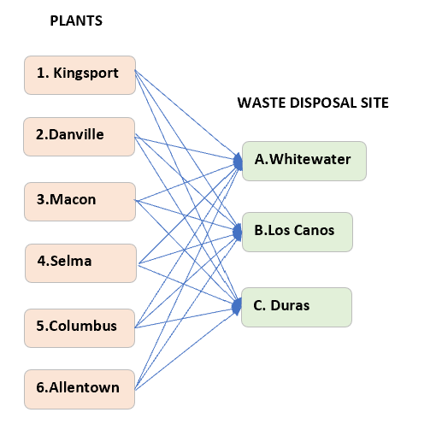

Transportation Network Routes

|  |  |  |  |
| --- | --- | --- | --- |
| **Shipping cost from plants to waste disposal sites** | | | |
| **Plant** | **Waste Disposal Site** | | |
| Whitewater | Los Canos | Duras |
| 1. Kingsport | 12 | 15 | 17 |
| 2.Danville | 14 | 9 | 10 |
| 3.Macon | 13 | 20 | 11 |
| 4.Selma | 17 | 16 | 19 |
| 5.Columbus | 7 | 14 | 12 |
| 6.Allentown | 22 | 16 | 18 |

|  |  |  |  |  |
| --- | --- | --- | --- | --- |
| **Supply** | |  | **Demand** | |
| **Plant** | **Waste/Week (bbl)** |  | **Waste Disposal Site** | **Maximum Demand** |
| 1. Kingsport | 35 |  | A.Whitewater | 65 |
| 2.Danville | 26 |  | B.Los Canos | 80 |
| 3.Macon | 42 |  | C.Duras | 105 |
| 4.Selma | 53 |  |  |  |
| 5.Columbus | 29 |  |  |  |
| 6.Allentown | 38 |  |  |  |
| **TOTAL** | **223** |  | **TOTAL** | **250** |

Here we found that this transportation model is unbalanced with demand exceeding the available supply. To solve this, a dummy supply is added to achieve even distribution.

|  |  |  |  |
| --- | --- | --- | --- |
| **Shipping cost from plants to waste disposal sites** | | | |
| **Waste Disposal Site** | | | |
| **Plant** | Whitewater | Los Canos | Duras |
| 1. Kingsport | 12 | 15 | 17 |
| 2.Danville | 14 | 9 | 10 |
| 3.Macon | 13 | 20 | 11 |
| 4.Selma | 17 | 16 | 19 |
| 5.Columbus | 7 | 14 | 12 |
| 6.Allentown | 22 | 16 | 18 |
| **7. Dummy** | 0 | 0 | 0 |

|  |  |  |  |  |
| --- | --- | --- | --- | --- |
| **Supply** | |  | **Demand** | |
| **Plant** | **Waste/Week (bbl)** |  | **Waste Disposal Site** | **Maximum Demand** |
| 1. Kingsport | 35 |  | A.Whitewater | 65 |
| 2.Danville | 26 |  | B.Los Canos | 80 |
| 3.Macon | 42 |  | C.Duras | 105 |
| 4.Selma | 53 |  |  |  |
| 5.Columbus | 29 |  |  |  |
| 6.Allentown | 38 |  |  |  |
| 7. Dummy | 27 |  |  |  |
| **TOTAL** | **250** |  | **TOTAL** | **250** |

**Model Formulation**

**Decision Variables:**

* *xij*​: Number of barrels of waste shipped from plant *i* to disposal site *j*.
* *i*=1,2,3,4,5,6,7 to *j*=A,B,C

**Objective Function:**

Minimize, *Z* = 12x1A +15x1B +17x1C +14x2A +9x2B +10x2C +13x3A +20x3B +11x3C +17x4A +16x4B +19x4C +7x5A +14x5B +12x5C +22x6A +16x6B +18x6C + 0x7A +0x7B +0x7C

Minimize the total transportation cost.

**Subject to Constraints:**

**S****upply Constraints:** The amount of waste shipped from each plant should be equal its supply.

*x*1*A*​+*x*1*B*​+*x*1*C* ​=35 (1. Kingsport)

*x*2*A*​+*x*2*B*​+*x*2*C* ​=26 (2. Danville)

*x*3*A*​+*x*3*B*​+*x*3*C*​ =42 (3. Macon)

*x*4*A*​+*x*4*B*​+*x*4*C*​ =53 (4. Selma)

*x*5*A*​+*x*5*B*​+*x*5*C*​ =29 (5. Columbus)

*x*6*A*​+*x*6*B*​+*x*6*C*​ =38 (6. Allentown)​

*x*7*A*​+*x*7*B*​+*x7C*​ =27 (7. Dummy)​

**Demand Constraints:** The amount of waste received at each disposal site should meet its demand.

​*x*1*A*​+*x*2*A*​+*x*3*A*​+*x*4*A*​+*x*5*A*​+*x*6*A*​=65 (A. Whitewater)

*x*1*B*​+*x*2*B*​+*x*3*B*​+*x*4*B*​+*x*5*B*​+*x*6*B*​=80 (B.Los Canos)

*x*1*C*​+*x*2*C*​+*x*3*C*​+*x*4*C*​+*x*5*C*​+*x*6*C*​=105 (C.Duras)​

**Non-negativity Constraints:** The number of barrels shipped must be non-negative.

*xij*​≥0 for all *i*,*j*

**Results:** The solution for this model formulation using Python is as below:

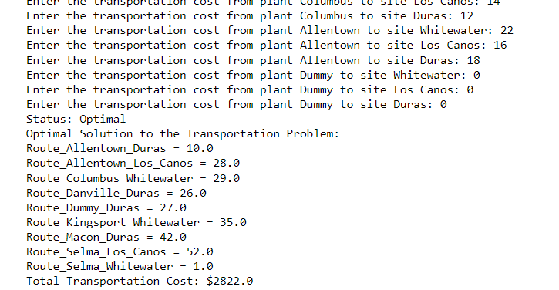

Thus, the following table represents the optimal solution to the transportation problem.

|  |  |  |  |  |
| --- | --- | --- | --- | --- |
| **From** | **To** | **Shipment unit** | **Cost per unit** | **Shipment cost** |
| 1.Kingsport | A.Whitewater | 35 | $12 | $420 |
| 2.Danville | C.Duras | 26 | $10 | $260 |
| 3.Macon | C.Duras | 42 | $11 | $462 |
| 4.Selma | A.Whitewater | 1 | $17 | $17 |
| 4.Selma | B.Los Canos | 52 | $16 | $832 |
| 5.Columbus | A.Whitewater | 29 | $7 | $203 |
| 6.Allentown | B.Los Canos | 28 | $16 | $448 |
| 6.Allentown | C.Duras | 10 | $18 | $180 |
| **Total Cost** |  |  |  | **$2822** |

The overall cost of transportation for the best option is $2822, if Miharja carries garbage straight from plants to disposal facilities. This cost is calculated by considering the coefficients (shipping costs) and the optimal flow values for each route.

But still, the rest of the demand at disposal site Duras (27bbl), cannot be fully met due to insufficient supply. To account for this shortfall, a dummy route was introduced in the optimization model. Overall, the solution optimally allocates the transportation of waste to meet demand at disposal sites while minimizing the total transportation cost.

1. **Develop a transshipment model in which each of the plants can be used as intermediate points to determine the optimal cost.**

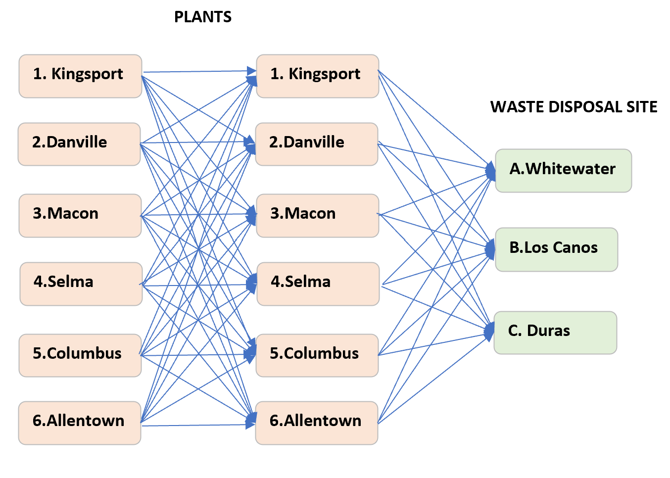

Transshipment Network Routes

The transportation model transforms into a transshipment model when each plant serves as an intermediary shipping point.. The additional decision variables included in the new model formulation as below:

**Model Formulation**

**Decision Variables:**

* x*hi​:* Number of barrels of waste shipped from plant *h* to intermediate plant *h*.
* x*ij*: Number of barrels of waste shipped from plant *i* to disposal site *j*.

where

*h*=1,2,3,4,5,6

*i*=1,2,3,4,5,6,7 (the same 6 plants as *h* but additional of 1 dummy supply)

*j*=A,B,C

**Objective Function:**

Minimize, *Z* = 6x12+ 4x13+ 9x14+ 7x15+ 8x16+ 6x21+ 11x23+ 10x24+ 12x25+ 7x26+ 5x31+ 11x32+ 3x34+ 7x35+ 15x36+ 9x41+ 10x42+ 3x43+ 3x45+ 16x46+ 7x51+ 12x52+ 7x53+ 3x54+ 14x56+ 8x61+ 7x62+ 15x63+ 16x64+ 14x65 + 12x1A +15x1B +17x1C +14x2A +9x2B +10x2C +13x3A +20x3B +11x3C +17x4A +16x4B +19x4C +7x5A +14x5B +12x5C +22x6A +16x6B +18x6C

Minimize the total transportation cost.

**Subject to Constraints:**

**Supply Constraints 1:** The amount of waste shipped from each plant should be equal its supply.

*x*1*A*​+*x*1*B*​+*x*1*C* ​=35 (1.Kingsport)

*x*2*A*​+*x*2*B*​+*x*2*C* ​=26 (2.Danville)

*x*3*A*​+*x*3*B*​+*x*3*C*​ =42 (3.Macon)

*x*4*A*​+*x*4*B*​+*x*4*C*​ =53 (4.Selma)

*x*5*A*​+*x*5*B*​+*x*5*C*​ =29 (5.Columbus)

*x*6*A*​+*x*6*B*​+*x*6*C*​ =38 (6.Allentown)​

**Supply Constraints 2:** The amount of waste shipped from each plant should be equal its supply.

*x*1*A*​+*x*1*B*​+*x*1*C* ​=35 (1.Kingsport)

*x*2*A*​+*x*2*B*​+*x*2*C* ​=26 (2.Danville)

*x*3*A*​+*x*3*B*​+*x*3*C*​ =42 (3.Macon)

*x*4*A*​+*x*4*B*​+*x*4*C*​ =53 (4.Selma)

*x*5*A*​+*x*5*B*​+*x*5*C*​ =29 (5.Columbus)

*x*6*A*​+*x*6*B*​+*x*6*C*​ =38 (6.Allentown)​

*x*7*A*​+*x*7*B*​+*x*7*C*​ =27 (7.Allentown)​

**Demand Constraints:** The amount of waste received at each disposal site should meet its demand.

​*x*1*A*​+*x*2*A*​+*x*3*A*​+*x*4*A*​+*x*5*A*​+*x*6*A*​=65 (A.Whitewater)

*x*1*B*​+*x*2*B*​+*x*3*B*​+*x*4*B*​+*x*5*B*​+*x*6*B*​=80 (B.Los Canos)

*x*1*C*​+*x*2*C*​+*x*3*C*​+*x*4*C*​+*x*5*C*​+*x*6*C*=105 (C.Duras)​

**Transshipment Constraint**: The amount of waste shipped from supply equal to amount received by demand

∑x*hh* - ∑x*ij =*0

**Non-negativity Constraints:** The number of barrels shipped must be non-negative.

*xhi*​ and x*ij* ≥0 for all *h*, *i*, and *j*

**Results:** The solution for this model formulation using Python is as below:

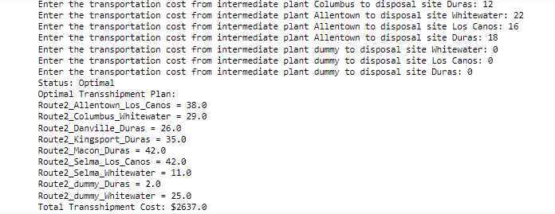

Hence, the most efficient resolution for this transshipment issue can be summarized in the subsequent table..

|  |  |  |  |  |  |
| --- | --- | --- | --- | --- | --- |
| **From Plants** | **To Intermediate Plants** | **Shipment unit** | **Cost per unit** | **Shipment cost** | **Total** |
| 1.Kingsport | 1.Danville | 16 | $6 | $96 | $597 |
| 2.Danville | 26 | $0 | $0 |
| 6.Allentown | 38 | $7 | $266 |
| 1.Kingsport | 3.Macon | 19 | $4 | $76 |
| 3.Macon | 42 | $0 | $0 |
| 4.Selma | 17 | $3 | $51 |
| 4.Selma | 5.Columbus | 36 | $3 | $108 |
| 5.Columbus | 29 | $0 | $0 |
|  |  |  |  |  |  |
| **From Intermediate Plants** | **To Waste Disposal Sites** | **Shipment unit** | **Cost per unit** | **Shipment cost** | **Total** |
| 1.Danville | B.Los Canos | 80 | $9 | $720 | $2033 |
| 3.Macon | C.Duras | 78 | $11 | $858 |
| 5.Columbus | A.Whitewater | 65 | $7 | $455 |
|  |  |  |  | **TOTAL** | **$2630** |

When transshipping waste within Miharja's plants and subsequently to disposal sites, the total transshipment cost for the optimal solution amounts to $2630. This cost is computed by taking into consideration the coefficients (shipping costs) and the optimal flow values for each route. Again, the remaining demand at the disposal site for Duras (27 barrels) cannot be entirely fulfilled due to inadequate supply. Hence, a dummy route was incorporated into the optimization model.

1. **Interpret the results and determine the best model for Sally to be implemented**

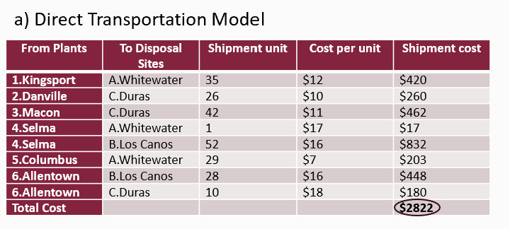

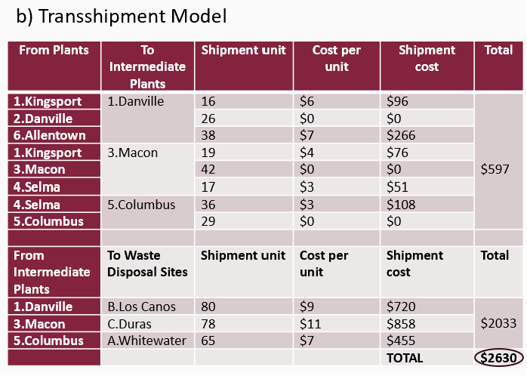

Upon analyzing the results, optimal cost for direct transportation from plants to disposal sites is $2882. Conversely, employing a transshipment strategy within each plants before onward transportation to disposal sites yields a total cost of $2630. From a cost perspective alone, the transshipment model appears as the more advantageous choice by presenting a solution with a lower optimal cost compared to the direct transportation model. This translates to a weekly cost savings of $192 for Miharja which is significant amount of cost that can be reduce.

In summary, the transshipment model stands as the best choice for Sally to implement in achieving cost efficiency with a noticeably reduced optimal cost.